DAY 21
Task 4:
Application is a simple Note Keeper built using Node.js, Express, and EJS that performs basic CRUD operations (Create, Read, Update, Delete) on notes.
- app.js (Backend) handles all server-side logic:
  - Starts the Express server.
  - Stores notes in an array.
  - Displays all notes when the page loads.
  - Adds new notes.
  - Updates existing notes.
  - Deletes notes.
- home.ejs (Frontend) is the user interface:
  - Displays all existing notes.
  - Provides a form to add new notes.
  - Provides Update and Delete buttons for each note.
  - Sends user actions to the server using form submissions.
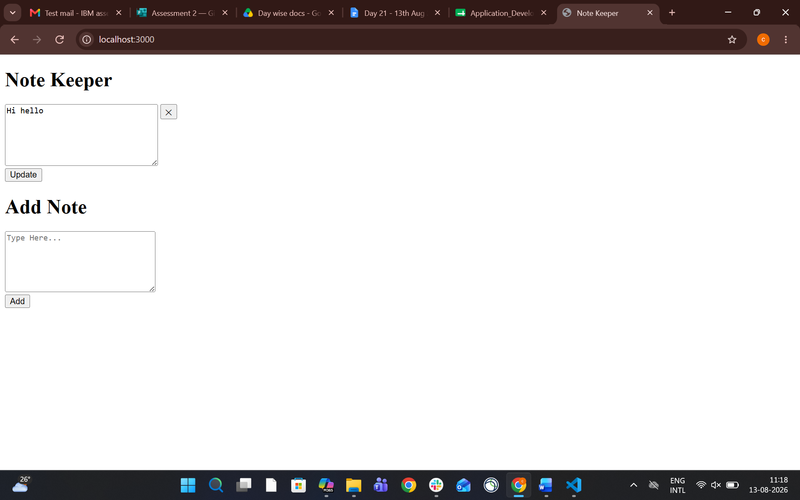
Task 5:
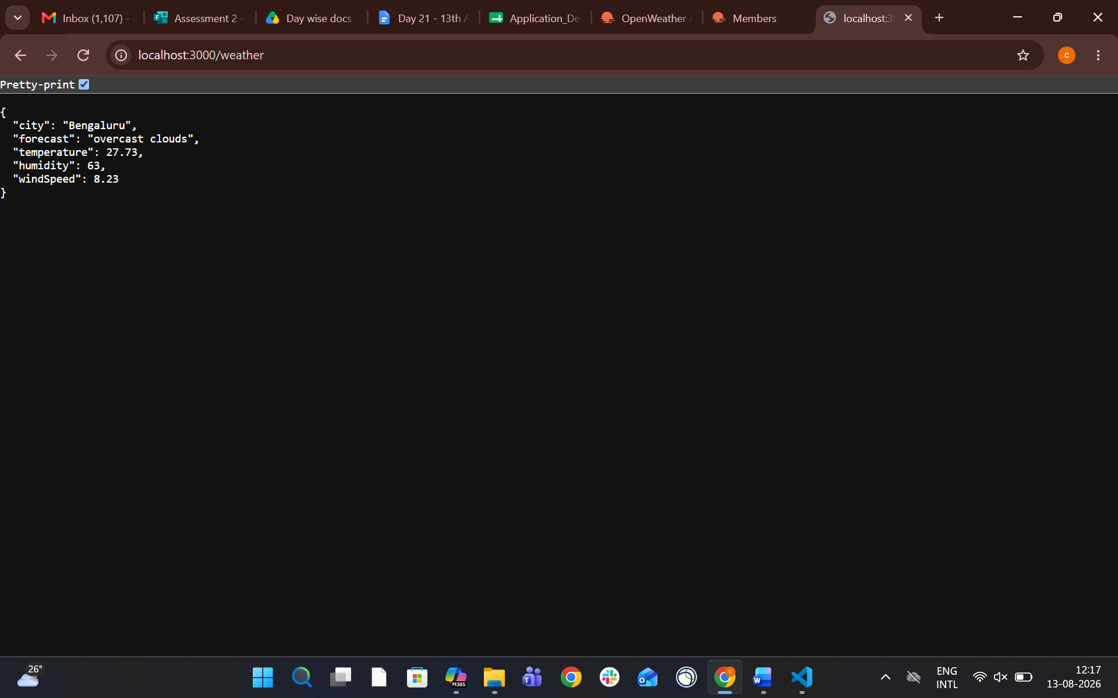
Task 6:
Mongoose is an Object Data Modeling (ODM) library for MongoDB and Node.js. It provides a structured way to interact with MongoDB by allowing developers to define schemas and models for their data.
Task 7:
True
Mongoose is commonly described as a bridge between Node.js and MongoDB because it provides a structured, schema-based way to interact with MongoDB from a Node.js application.
Instead of writing raw MongoDB queries, Mongoose lets you:
- Define schemas for your data
- Create models to interact with collections
- Perform CRUD operations easily
- Add validation and middleware
- Manage relationships between collections

Task 8:
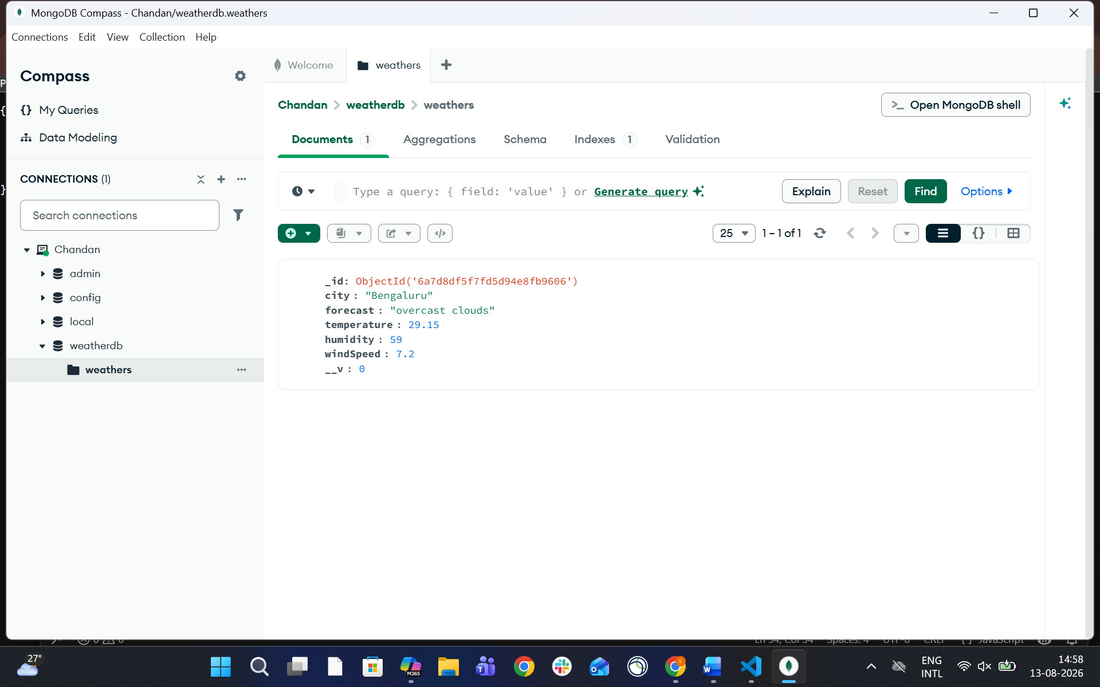
Task 9:

